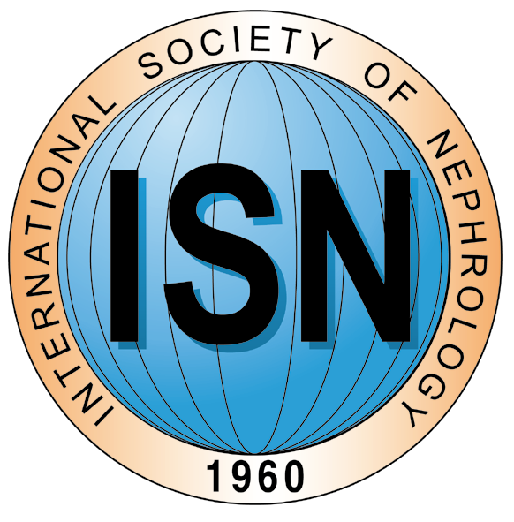 | 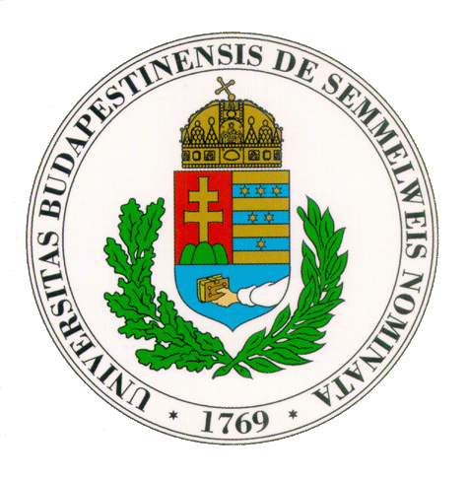 | 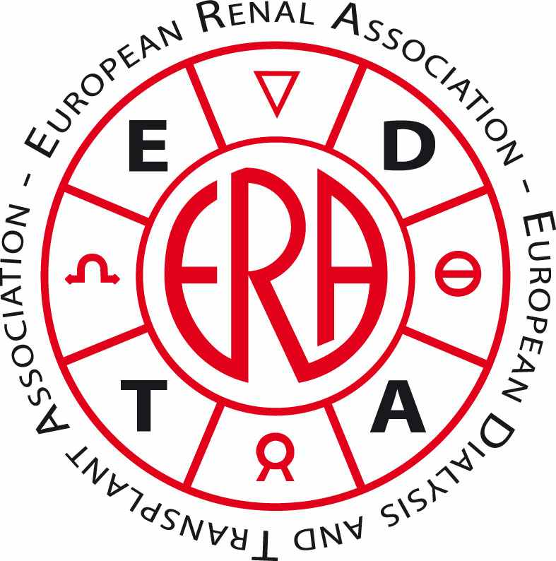

The 21st Budapest Nephrology School
Nephrology, Hypertension, Dialysis, Transplantation

Under the Auspices of
ISN, ERA-EDTA, RPS, IFKF and ISP
26–31 August, 2014
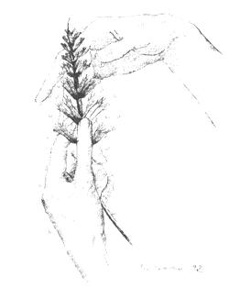

In conjunction with Young Nephrologists’ Platform (24-25, August, 2014)
and the 12th International Symposium on Wine and Health and on the occasion of the 9th World Kidney Day

Semmelweis University
International Nephrology Research & Training Center
Worldwide Hungarian Medical Academy
Vanderbilt University Medical Center
University of Toronto, Avicenna College
International Society for Pathophysiology
Hungarian Kidney Foundation (Charity Reg. Nr. 596/1987)
Dear Colleague,

Budapest Nephrology School is a one-week, English speaking, internationally recognized, CME refresher nephrology course which has been organized by the Hungarian Kidney Foundation at the Semmelweis University for the past 20 years, under the auspices of ISN and ERA-EDTA. The school is accredited worldwide by EU in Brussels. The School published a book titled “Nephrology, Hypertension, Dialysis and Transplantation” edited by T. Andreoli, E. Ritz and L. Rosivall (2005). The new, 3rd edition of the book has just appeared as an e-book and will be printed soon.

During the one-week program, our distinguished international speakers provide updates in nephrology, hypertension, dialysis and transplantation. We cover the field from molecule to bedside, from the most recent scientific advances to the current clinical approaches. Workshops provide the possibility for close interaction with the faculty in small groups. Participants are encouraged to present their posters, raise questions and consult other colleagues on problematic cases. Programs are also arranged to visit quality dialysis and research units. The Budapest Nephrology School has always kept high standards and performed successfully with international positive feed-backs. So far doctors from 65 countries have attended the school. Our success is reflected by the increasing number of participants who have repeatedly attended the school.

The school is proud of its faculty who has represented the international most recognized experts in the field from the very beginning. We believe that the school is also a unique opportunity for our colleagues to spend some time in Budapest and while enjoying the cultural, architectural, social, historical beauties and the special Hungarian hospitality of a thousand years old country, meet with colleagues worldwide and get the refresher in the field from the best.

The 21st Budapest Nephrology School is held in conjunction with Young Nephrologists’ Platform (24-25, August, 2014) and the 12th International Symposium on Wine and Health and on the occasion of the 9th World Kidney Day.

The 21st Budapest Nephrology School was accredited by the European Accreditation Council for Continuing Medical Education (EACCME) for 30 European CME credits (ECMEC). The Course included 52 hours of scientific lectures and a final examination which can be locally evaluated according to national standards (in Hungary it is equal to 50 CME credits).

Looking forward to seeing you in Budapest soon.

Sincerely yours,
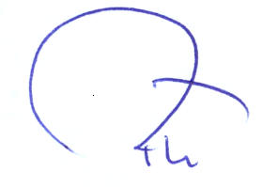

László Rosivall, MD, PhD, DSc
President
Semmelweis University,
Faculty of Medicine
Department of Pathophysiology
International Nephrology Research & Training Center
Website: www.bns-hungary.hu
E-mail: rosivall.laszlo@med.semmelweis-univ.hu
FACULTY

Mustafa Arici, M.D
Professor of Nephrology
Hacettepe University Faculty of Medicine
Department of Nephrology
06100-Sihhiye, Ankara-TURKEY
Tel: +90-312-324 -3109
Fax: +90-312-311- 3958
aricim@gmail.com

Mónika Beck Göőz, M.D., Ph.D.
Associate Professor
Division of Nephrology/
Department of Medicine
Medical University of South Carolina
Charleston, SC, USA
Tel: +01-843-876-2338
beckm@musc.edu

Anthony J. Bleyer, M.D., M.S.
Professor
Section on Nephrology
Wake Forest University School of Medicine
Winston-Salem, NC 27157
Phone: 336-716-4513
Fax: 336-716-4318
ableyer@wakehealth.edu

Ernő Péter Botos, MD
Professor and Head
Institute for Viticulture and
Enology
Corvinus University
Úrihegy 5/A
H-6000, Kecskemét
Hungary
Tel: +36-76-494-888
Fax: +36-76-494-924
botosep@upcmail.hu

Marc E. De Broe, MD, PhD
Professor of Medicine
University of Antwerp
Laboratory of Pathophysiology
Universiteitsplein 1
2610 Wilrijk/Antwerpen, Belgium
Tel: +32-9-3485515
Fax: +32-3-820-2592
marc.debroe@uantwerpen.be

Christopher T Chan, MD
R Fraser Elliott Chair of Home Dialysis
Associate Professor of Medicine - University of Toronto
Deputy Director – Division of Nephrology
Tel: +1-416-340-3073
Fax: +1-416-340-4999
christopher.chan@uhn.ca

Barry I. Freedman, M.D., F.A.C.P.
John H. Felts III Professor of Internal Medicine
Chief, Section on Nephrology
Wake Forest School of Medicine
Medical Center Boulevard
Winston-Salem, NC 27157-1053
Tel: +336.716.6192
Fax: + 336.716.4318
bfreedma@wakehealth.edu

Simin Goral, MD
Professor of Medicine
University of Pennsylvania
Medical Center
3400 Spruce street
One Founders
19104 - Philadelphia, PA, U.S.A.
Tel: +1-215-662-3460
Fax: +1-215-615-0349
simin.goral@uphs.upenn.edu

Ágnes Haris, MD, PhD
Deputy Chief of Nephrology Section of
St. Margit Hospital
Bécsi út 132.,
1032 Budapest, Hungary
Tel: +36-1-250-2170
Fax: +36-1-439-0276
agnesharis@hotmail.com

J. Harold Helderman, MD
Professor of Medicine, Microbiology and Immunology
Assistant Dean (retired), Vanderbilt University School of Medicine
Vanderbilt University Medical Center
Medical Director, Vanderbilt Transplant Center
21st Avenue South Garland
S-3223 Medical Center North
Nashville, TN 37232-2372
United States
Tel: +1-615-322-6976
Fax: +1-615-343-7156
hal.helderman@vanderbilt.edu

Eva Honsova, MD, PhD
Pathology Department, Institute for Clinical and Experimental Medicine, Prague, Czech Republic
eva.honsova@ikem.cz

Sadayoshi Ito, Md, PhD
Professor of Medicine and Head,
Nephrology, Endocrinology and Hypertension
Tohoku University
1-1-2-chome, Katahira, Aoba-ku,
Sendai 980-0077 JAPAN
db554@med.tohoku.ac.jp

Kamyar Kalantar-Zadeh, MD, MPH, PHD
FAAP, FACP, FASN, FAHA, FNKF
Chief, Division of Nephrology & Hypertension
Professor of Medicine, Pediatrics and Public Health
University of California Irvine, School of Medicine
Email: kkz@uci.edu
Adjunct Professor of Epidemiology
Dept. Epidemiology, UCLA Fielding School of Public Health, Los Angeles, CA
Email: kamkal@ucla.edu
Physician and Principal Investigator
VA Long Beach Healthcare System‎
5901 East 7th Street, Long Beach, CA 90822
Tel: (562) 826-8000
kamyar.kalantar-zadeh@va.gov

Csaba P. Kövesdy, MD, FASN
Fred Hatch Professor of Medicine
Director, Clinical Outcomes and Clinical Trials Program
University of Tennessee Health Science Center
956 Court Ave., Room B222, Memphis TN 38163
Tel: (901) 448-2985
Chief of Nephrology
Memphis VA Medical Center
Nephrology Section (111B)
1030 Jefferson Ave., Room G409
Memphis TN 38104
Tel.: (901) 577-7278 x6909/6918
Fax: (901) 577-7539
ckovesdy@uthsc.edu

Róbert Langer, MD, PhD
Professor
Department of
Transplantation and Surgery,
Semmelweis University
Baross u. 23.
H-1082, Budapest
Hungary
Tel: +36-1-267-6000
Fax: +36-1-317-2166
langer.robert@med.semmelweis-univ.hu

Francesco Locatelli, MD, PhD
Professor of Nephrology
Ospedale Alessandro Manzoni
Divisione di Nefrologia e Dialisi
Via Dell'Eremo 9-11
23900 Lecco
Italy
Tel: +39-0341-489850
Fax: +39-0341-489860
f.locatelli@ospedale.lecco.it

Zoltán Máthé MD, PhD, FRCSC
Associate Professor of Surgery
Chair of the Department of
Transplantation and Surgery,
Semmelweis University
Baross u. 23.
H-1082, Budapest
Hungary
Tel: +36-1-267-6000/80150
Fax: +36-1-317-2166
mathezol@hotmail.com

Krisztina Mészáros, MD
Krisztina.Meszaros@med.uni-heidelberg.de

Miklos Zsolt Molnar, MD, PhD
Associate Professor of Medicine
Division of Nephrology, University of Tennessee Health Science Center
Memphis, TN, USA
mzmolnar@uthsc.edu

István Mucsi, MD, PhD
Associate Professor of Medicine, University of Toronto
Division of Nephrology, Multi-Organ Transplant Program
University Health Network, Toronto General Hospital
and
Department of Pathophysiology
and Institute of Behavioural Sciences
Semmelweis University, Budapest
istvan@nefros.net

Márta Novák, MD, PhD
Associate Professor
Semmelweis University
Institute of Behavioural Sciences and Associate Professor
Dept. of Psychiatry, University of Toronto
Nagyvárad tér 4., 1089 Budapest, Hungary
Tel: +36-1-210-2930
Fax: +36-1-210-1220
marta@nefros.net

János Peti-Peterdi, MD, PhD
Professor
Zilkha Neurogenetic Institute
Keck School of Medicine
University of Southern California
1501 San Pablo st.
90089-2821 Los Angeles, California
Tel: +1-323-442-4337
Fax: +1-323-442-4466
petipete@med.usc.edu

Kálmán Polner, MD
Chief of Nephrology Section of
St. Margit Hospital
Bécsi út 132., 1032 Budapest, Hungary
Tel: +36-1-250-2170
Fax: +36-1-439-0276
polner.kalman@hotmail.com

Giuseppe Remuzzi, MD, FRCP
Director Department of Medicine, Bergamo Hospital
Research Coordinator, Mario Negri Institute for Pharmacological Research
President, International Society of Nephrology (ISN)
Via Stezzano, 87
24126 Bergamo, Italy
tel. +39 03542131
fax: +39 035319331
giuseppe.remuzzi@marionegri.it

György Reusz, MD, PhD, DSc
Professor
I. Department of Pediatrics
Semmelweis University
Bókay J. u. 53.
H-1083 Budapest
Hungary
Tel: +36-1-324-7795
Fax: + 36-1-324-7795
reusz.gyorgy@med.semmelweis-univ.hu

Eberhard Ritz, Dr. Dr. med. h.c. mult.
FRCP(London und Edinburgh)FACP
Past President of International Society of Nephrology (ISN)
Professor of Medicine
Dept. Internal Medicine
Division Nephrology
Im Neuenheimer Feld 162
D-69120 Heidelberg
Germany
Tel: +49-6221-189976
Fax: +49 (0) 6221 603302
bueroritz@t-online.de

László Rosivall, MD, PhD, DSc
Professor of Pathophysiology
Hungarian Academy of Sciences
and Semmelweis University
Research Group for Pediatrics and Nephrology
Institute of Pathophysiology
Faculty of Medicine
Semmelweis University, Budapest, Nagyvárad tér 4., 1089, Hungary
Tel/Fax: +36-1-2100-100
rosivall.laszlo@med.semmelweis-univ.hu

Gerald Schulman, MD, FASN
Professor of Medicine
Co-Director of the Clinical Trials Center in Nephrology
Vanderbilt University School of Medicine
S-3223 Medical Center North
Nashville, Tn. 37232
USA
Tel: +1-615-322-6976
Fax: +1-615-343-7156
gerald.schulman@vanderbilt.edu

Peter Stenvinkel, MD
Professor of Renal Medicine
Dept of Renal Medicine K56
Karolinska university Hospital at Huddinge
Karolinska Institutet
141 86 Stockholm
Tel +46-8-58582532
Mobile +46-73-6998771
Fax +46-8-7114742
Peter.Stenvinkel@ki.se

Balázs Szamosfalvi, MD
Director, In-Patient Dialysis and CRRT
Henry Ford Hospital
2799 W. Grand Blvd.
Detroit, MI 48202, U.S.A.
Tel: +1-313-916-2702
Fax: +1-313-916-2554
bszamos1@hfhs.org

Ágoston Szél, MD
President of Semmelweis University
1088 Budapest,
Üllői út 26.
Tel: +36-1-459-1500

Jens Titze, PD Dr. med.
Department of Nephrology and Hypertension and
Nikolaus-Fiebiger-Centre for Molecular Medicine
Friedrich-Alexander-University Erlangen-Nuremberg
Glückstr. 6
91054 Erlangen
Germany
Tel: +49-9131-8539300
Fax: +49-9131-8539311
jtitze@molmed.uni-erlangen.de

Tibor Tóth, MD, PhD
Chief of Pathology Section of
St. Margit Hospital
Bécsi út 132., 1032 Budapest, Hungary
Tel: +36-1-250-2170/1156
Fax: +36-1-439-0276
toti52@freemail.hu

Andrzej Wiecek, M.D., PhD., Professor,
Head of the Dept. of Nephrology, Endocrinology and Metabolic Diseases
Medical University of Silesia,
Francuska 20-24 Str.
40-027 Katowice, Poland
Tel: +48-32-255-2695,
Fax: +48-32-255-3726
awiecek@spskm.katowice.pl

Program

AUGUST 26 (Tuesday)

08:00 – 09:00 REGISTRATION
Venue:
Department of Transplantation and Surgery
Semmelweis University
Baross street 23.
1082 Budapest

OPENING

09:00 – 09:20 Welcome Addresses and Official Opening
L. Rosivall, President of the Hungarian Kidney Foundation
E. Ritz, Past President of the International Society of Nephrology
A. Wiecek, President of European Renal Association – European Dialysis Transplant Association
Á. Szél, President of the Semmelweis University, Budapest, Patronage of the School
Gy. Reusz, President of the Hungarian Nephrological Society, Budapest
Z. Máthé, Chair of the Department of Transplantation and Surgery, Semmelweis University

FROM MOLECULES TO BEDSIDE, FROM THEORY TO PATIENT CARE

Moderator:

09:20 – 09:50 Kidney Biomimicry
09:50 – 10:00 Discussion
Peter Stenvinkel, Sweden

10:00 – 10:30 Obesity and Kidney Diseases
10:30 – 10:40 Discussion
Peter Stenvinkel, Sweden

10:40 – 11:10 Autosomal Dominant Interstitial Kidney Disease
11:10 – 11:20 Discussion
Anthony J. Bleyer, U.S.A.

11:20 – 11:50 Disaster Nephrology
11:50 – 12:00 Discussion
Mustafa Arici, Turkey

12:00 – 12:50 Lunch

Moderator:

12:50 – 13:20 News in Diabetic Nephrology
13:20 – 13:30 Discussion
Eberhard Ritz, Germany

13:30 – 14:00 Genetics of Diabetic Kidney Disease and Essential Hypertension
14:00 – 14:10 Discussion
Barry I Freedman, U.S.A.

14:10 – 14:40 Genetics of Non-Diabetic Kidney Disease
14:40 – 14:50 Discussion
Barry I Freedman, U.S.A.

14:50 – 15:20 Coffee Break

Moderator:

15:20 – 15:50 Renal Renin-Angiotensin System
15:50 – 16:00 Discussion
János Peti-Peterdi, U.S.A.

16:00 – 16:30 Visualization of Kidney Tissue Regeneration
16:30 – 16:40 Discussion
János Peti-Peterdi, U.S.A.

12TH INTERNATIONAL SYMPOSIUM ON WINE AND HEALTH
in conjunction with the 21st Budapest Nephrology School

16:40 – 17:10 Effects of Alcohol and Wine on Health
17:10 – 17:20 Discussion
Eberhard Ritz, Germany

18:30 – 22:00 Elaboration and Presentation of Hungarian Wines
Symposium Dinner

18:30 – 18:40 Presidential Greetings
László Rosivall, Hungary

18:40 – 19:10 Elaboration and Presentation of Hungarian Wines
Ernő Péter Botos, Hungary

19:10 – 22:00 Dinner
Special Hungarian Dishes
Selected Quality Wines from the Best Known Hungarian Cellars

AUGUST 27 (Wednesday)

Moderator:

09:00 – 09:30 Circadian Oscillation in the Kidney
09:30 – 09:40 Discussion
Krisztina Mészáros, Eberhard Ritz, Germany

09:40 – 10:10 Tubular Transport
10:10 – 10:20 Discussion
János Peti-Peterdi, U.S.A.

10:20 – 10:50 Tissue Sodium in Normotensive individuals and Hypertensive Patients
10:50 – 11:00 Discussion
Jens Titze, Germany, U.S.A.

11:00 – 11:30 Coffee Break

Moderator:

11:30 – 12:00 Lymph, Guts and Hypertension-Hypothesis?!
12:00 – 12:10 Discussion
Jens Titze, Germany, U.S.A.

12:10 – 12:40 Forefront Studies Concerning Aldosterone and CKD
12:40 – 12:50 Discussion
Eberhard Ritz, Germany

12:50 – 13:40 Lunch

Moderator:

13:40 – 14:10 FGF23: An update for Clinicians
14:10 – 14:20 Discussion
Csaba P. Kövesdy, U.S.A.

14:20 – 14:50 Renal Pharmacology
14:50 – 15:00 Discussion
Marc E. De Broe, Belgium

15:00 – 15:30 Coffee Break

Moderator:

15:30 – 16:00 Chonic Kidney Disease – A Clinical Condition of Premature Aging
16:00 – 16:10 Discussion
Peter Stenvinkel, Sweden

16:10 – 16:40 My Most Interesting Cases
16:40 – 16:50 Discussion
Presented by Members of the Faculty

16:50 – 17:20 Buffet

17:20 – 18:10 Visit of the Historical Building of the Semmelweis University

20:00 – 21:00 ORGAN CONCERT
Venue: St. Stephen Basilica
1051 Budapest, St. Stephen square

AUGUST 28 (Thursday)

Moderator:

09:00 – 09:30 Estimation and Measurement of GFR, Past, Present and Future
09:30 – 09:40 Discussion
Mustafa Arici, Turkey

09:40 – 10:10 Nephrotoxicity
10:10 – 10:20 Discussion
Marc E. De Broe, Belgium

10:20 – 10:50 The Kidney in Heart Failure
10:50 – 11:00 Discussion
Sadayosi Ito, Japan
11:00 – 11:30 Coffee Break

Moderator:

11:30 – 12:00 The Kidney and Metabolism
12:00 – 12:10 Discussion
Sadayosi Ito, Japan

12:10 – 12:40 My Most Interesting Cases
12:40 – 12:50 Discussion
Presented by of the Participants

12:50 – 13:40 Lunch

PSYCHONEPHROLOGY, REHABILITATION

Moderator:

13:40 – 14:10 Complex Approach to Patients with CKD
14:10 – 14:20 Discussion
Ágnes Haris, Kálmán Polner, Hungary

14:20 – 14:50 Rehabilitation of Patients with CKD, a Hungarian Example
14:50 – 15:00 Discussion
Kálmán Polner, Ágnes Haris, Hungary

15:00 – 15:30 Psychonephrology: the Psychosocial Impact of Chronic Kidney Disease
15:30 – 15:40 Discussion
Márta Novák, Canada, Hungary

15:40 – 16:10 Coffee Break

CLINICAL NEPHROLOGY

Moderator:

16:10 – 16:40 Regulation of Bioenergetics in PKD and CKD
16:40 – 16:50 Discussion
Mónika Beck Göőz, U.S.A.

16:50 – 17:20 Clinical Approach to Polycystic Kidney Disease
17:20 – 17:30 Discussion
György Reusz, Hungary

17:30 – 18:00 Buffet

20:00 – 21:00 BOAT TOUR ON THE DANUBE

AUGUST 29 (Friday)

RENAL REPLACEMENT THERAPY

Moderator:

08:40 – 09:10 Dialysis, 2014
09:10 – 09:20 Discussion
Francesco Locatelli, Italy

09:20 – 09:50 Haemodiafiltration
09:50 – 10:00 Discussion
Francesco Locatelli, Italy

10:00 – 10:30 Novel Extracorporeal Support Techniques for Patients with SIRS
10:30 – 10:40 Discussion
Balázs Szamosfalvi, U.S.A.

10:40 – 11:10 Coffee Break

Moderator:

11:10 – 11:40 Impact of Recipients’ Obesity on the Outcome of Kidney Transplantation
11:40 – 11:50 Discussion
Miklós Zs. Molnár, U.S.A.

11:50 – 12:20 Cardiovascular Risk Reduction in Kidney Transplant Recipients
12:20 – 12:30 Discussion
István Mucsi, Canada, Hungary

12:30 – 13:00 Polyoma Virus Infection
13:00 – 13:10 Discussion
J. Harold Helderman, U.S.A.

13:10 – 13:40 Eurotransplant and Hungary
13:40 – 13:50 Discussion
Róbert Langer, Hungary

Moderators:

13:50 – 14:20 “Meet the Professors” - Discuss Your Own Questions with the Professors

14:20 – 15:00 Lunch

15:00 – 19:00 SIGHTSEEING TOUR, PARLIAMENT VISIT

AUGUST 30 (Saturday)

Venue: B. Braun Avitum, Aesculap Academy
1115 Budapest, Halmi u. 20-22.
(Transportation will be provided.)

CLINICAL NEPHROLOGY

Moderator:

09:00 – 09:30 Renal Denervation
09:30 – 09:40 Discussion
Andrzej Wiecek, Poland

09:40 – 10:10 Hyponatremia
10:10 – 10:20 Discussion
Kamyar Kalantar-Zadeh, U.S.A.

10:20 – 10:50 Role Lowering Phosporus
10:50 – 11:00 Discussion
Kamyar Kalantar-Zadeh, U.S.A.

11:00 – 11:30 Coffee Break

Moderator:

11:30 – 12:00 Atypical HUS - a Disorder of Complement Regulation
12:00 – 12:10 Discussion
Giuseppe Remuzzi, Italy

12:10 – 12:40 Dialysis and Renal Transplantation: Where are we Coming from and What we Would Like (Possibly) to Achieve?
12:40 – 12:50 Discussion
Giuseppe Remuzzi, Italy

12:50 – 13:40 Lunch

Moderator:

13:40 – 14:10 Pulmonary Hypertension in Patients with CKD/Dialysis
14:10 – 14:20 Discussion
Gerald Schulman, U.S.A.

14:20 – 14:50 Live Kidney Transplantation and Barrier to Kidney Donation
14:50 – 15:00 Discussion
Simin Goral, U.S.A.

15:00 – 15:30 Hepatitis C in Transplantation
15:30 – 15:40 Discussion
Simin Goral, U.S.A.

15:40 – 16:10 Coffee Break

Moderator:

16:10 – 16:40 Present and Future of Home Dialysis
16:40 – 16:50 Discussion
Cristopher Chan, Canada

16:50 – 17:20 Determinants of Training and Technique Failure in Home Hemodialysis
17:20 – 17:30 Discussion
Cristopher Chan, Canada

POSTER SESSION

Moderators:

17:30 – 18:30 Discussion with Wine

18:30 – 20:00 FAREWELL RECEPTION

AUGUST 31 (Sunday)

RENAL PATHOLOGY

Moderator:

07:40 – 08:10 Expanding Spectrum of Diseases Associated with Plasma Cell Dyscrasias
08:10 – 08:20 Discussion
Eva Honsova, Czech Republic

08:20 – 08:50 Renal Pathology-Transplantation
08:50 – 09:00 Discussion
Eva Honsova, Czech Republic

09:00 – 09:30 Pathology Quiz
09:30 – 09:40 Discussion
Tibor Tóth, Hungary

09:40 – 10:10 Coffee Break

EXAMINATION

10:10 – 11:10 Test

11:10 – 12:40 Machine Perfusion: New Perspectives in Kidney Transplantation
12:40 – 12:50 Discussion
Zoltán Máthé, Hungary

12:50 – 13:50 Lunch

CONCLUDING REMARKS
13:50 – 14:10 László Rosivall, Hungary

