COURSE ON
EVIDENCE-BASED LABORATORY MEDICINE

organised by the Committee on Evidence-Based Laboratory Medicine of IFCC

under the auspices of IFCC/FESCC and in collaboration with the
Screening and Diagnostic Test Methods Group
of the Cochrane Collaboration

21-24 September 2005
Budapest, Hungary

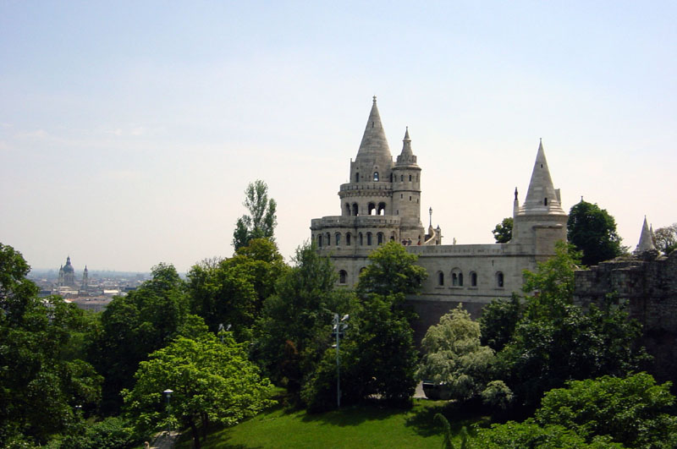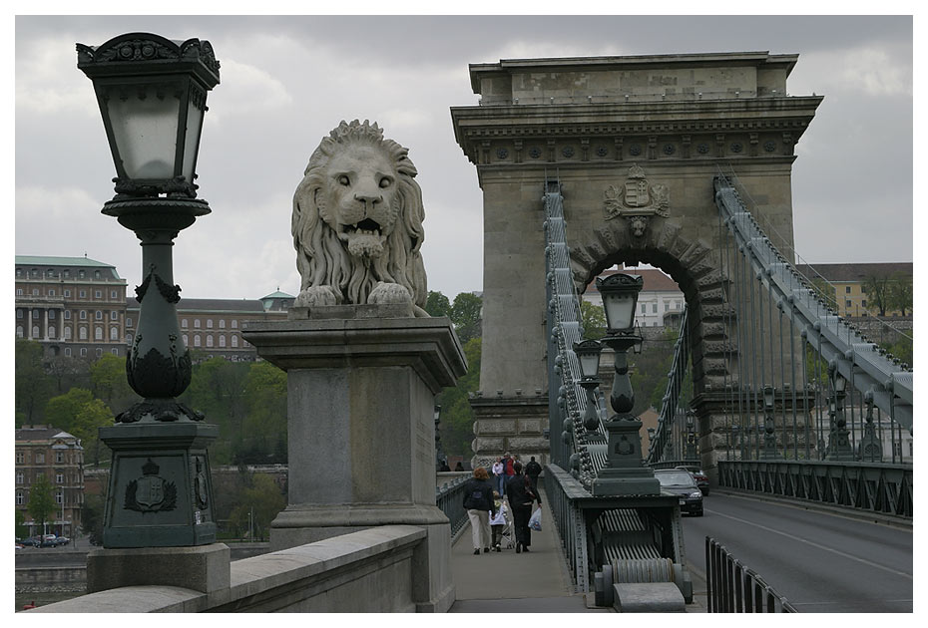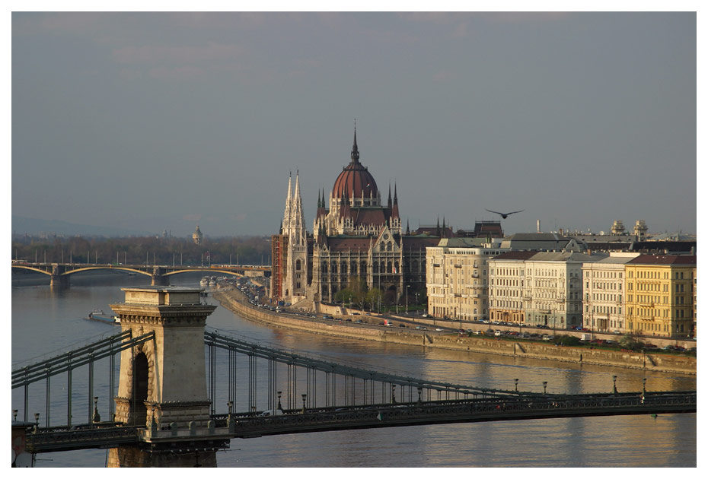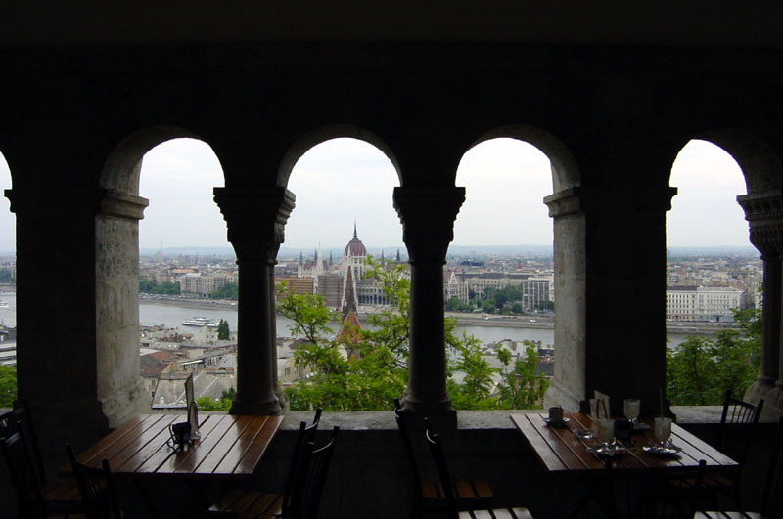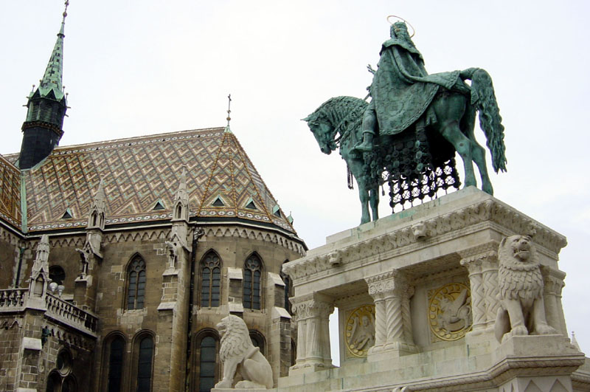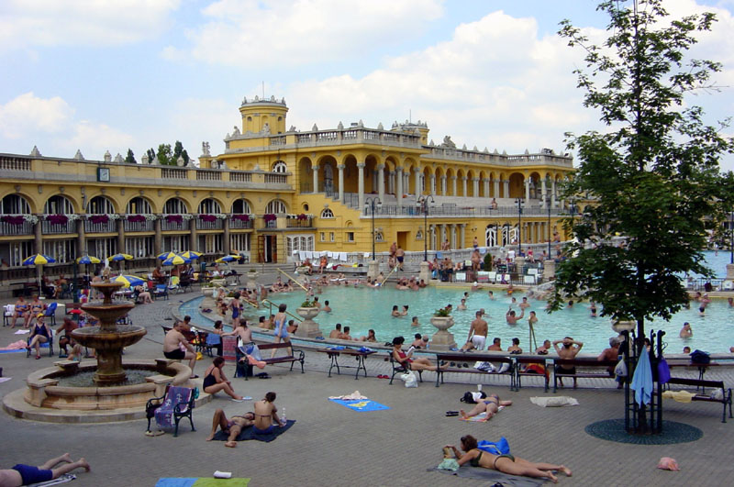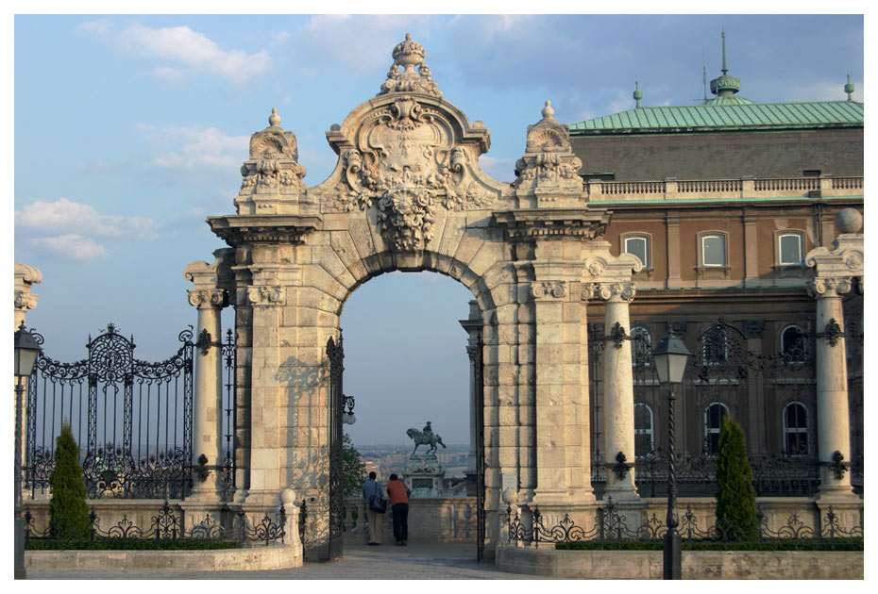



COURSE DESCRIPTION

AIMS AND OBJECTIVES
This international “train the trainers” course aims at disseminating the methodology of evidence-based laboratory medicine (EBLM).

Key objectives of the workshop are to help participants to:
- improve their ability to formulate questions, and systematically find and evaluate the evidence about diagnostic interventions;
- practise, teach and disseminate the methods of EBLM in their own countries.

Participants will obtain skills in:
- systematically
- formulating questions and designing studies,
- searching for the evidence,
- critically appraising the evidence, and
- interpreting the evidence;
- implementing research findings in clinical practice;
- teaching basic EBLM terms and methods,
- using EBLM in clinical practice and research.

WHO IS THIS COURSE FOR?
This course is primarily designed for laboratory professionals and other health care professionals, researchers and guideline developers with some background knowledge of and interest in evidence-based laboratory medicine. Participants with past experience in EBM or EBLM and willingness to cascade these skills in their own environment have an advantage (see Registration Information).

COURSE DESIGN
The course design is based on a training model by CASP International (Critical Appraisal Skills Program, originated from Oxford, UK).
The workshop consists of four modules, focussing on the following topics:
- Introduction to EBLM – question formulation and study design (day 1)
- Searching and appraising the evidence (day 2)
- Analysis and synthesis of the evidence (day 3)
- Using the evidence (day 4)

Each workshop module consists of introductory talks and interactive small group work followed by plenary feed-back sessions. The detailed preliminary programme of the course is attached. The organisers reserve all rights to make changes to the programme.

Introductory talks
A slide presentation precedes each small group work, and covers the theory and methodology that will be used in the practical workshop. The talks are usually combined with activities involving group work, exercises and feed-back in order to involve participants in active learning and sharing of experience.

Small group work
Participants will form small groups of approximately 8-10 people. The groups will stay the same throughout the course in order to allow small group learning and group dynamics to develop. The aim of small group work is to develop practical skills in EBLM methodology, including question formulation, selecting the appropriate study design, searching and critically appraising the evidence. The successful completion of most small group sessions requires some pre-workshop reading of case scenarios and corresponding articles. Small group discussions also provide an opportunity to share experience and to exchange views and approaches of participants. The interactive, problem-based small group session is led by a facilitator whose task is not to give the right answers, but to help the group to find the best solutions and come to a consensus view, which will then be presented in the plenary feed-back session.

Each small group session starts with voluntary nomination of the persons who will
- read out and explain the task of the workshop;
- summarize the consensus view of the group in the plenary feedback session;
- keep the time.

Plenary feed-back
Following on from a small group work, these feed-back sessions will allow participants to share their experience and small group discussions with the whole group. Group representatives will present the consensus views and opinions of small groups, and the facilitator of the feed-back session summarizes the different answers. The plenary feed-back sessions provide an opportunity to re-discuss and clarify issues that remained unsolved in the small group work, and reiterate some key definitions or methods described in the introductory talk.

Lecturers’ and facilitators’ feed-back
At the end of each day, lecturers and facilitators discuss how the workshops went, what went well or wrong, and how things could be improved next time. These daily round-up sessions are very useful when planning future workshops, and also in adjusting the programme of the next day according to participants’ needs and skills. Therefore, comments from participants regarding the programme during the small group works or the plenary discussions are encouraged and welcome!

Summary and evaluation
Each participant will be requested to fill in a workshop assessment form, which will investigate how individual aims and learning objectives were fulfilled, what participants liked or disliked, what questions remained unanswered. Participants’ reply will be very valuable to organisers in guiding them how to improve similar workshops in the future.

The assessment questionnaire is anonymous. The form should be filled in during the workshops and handed over to the organisers on the last day of the course!

OFFICIAL LANGUAGE
The official language of the course is English.

CME CREDITS

The course will be awarded 28 CME credit points. Certificates of CME credits will be given to all participants at the end of the course.

LECTURERS AND FACILITATORS
Lecturers and facilitators represent key experts in the field, including members of the Screening and Diagnostic Test Methods Group (SDT-MG) of the Cochrane Collaboration (CC) and the Committee on Evidence-based Laboratory Medicine (C-EBLM) of IFCC (www.ifcc.org):

Lecturers and facilitators:
Patrick Bossuyt, Member of SDT-MG of CC, University of Amsterdam (The Netherlands)
Robert Christenson, member of C-EBLM, chair of EBM working group of AACC (USA)
Jon Deeks, Member of SDT-MG of CC, University of Oxford (UK)
Matthias Egger, Member of SDT-MG of CC, University of Bern (Switzerland)
Paul Glasziou, Director of the Centre for Evidence-based Practice, Member of SDT-MG of CC, University of Oxford (UK)
Andrea Rita Horvath, chair of C-EBLM, University of Szeged (Hungary)
Wytze Oosterhuis, consultant of C-EBLM, St. Elisabeth Hospital, Tilburg (The Netherlands)
Daniel Pewsner, Member of SDT-MG of CC, University of Bern (Switzerland)
Christopher Price, Bayer Health Care, Newbury (UK)
Sverre Sandberg, former chair and consultant of C-EBLM, University of Bergen (Norway)

Facilitators:
Peter Bunting, corresponding member of C-EBLM, The Ottawa Hospital (Canada)
Katalin Soos, librarian, University of Debrecen (Hungary)
Marta Viragos, librarian, University of Debrecen (Hungary)
Joseph Watine, member of C-EBLM, Hôpital de Rodez (France)
John Whitfield, corresponding member of C-EBLM, Royal Prince Alfred Hospital, Sydney (Australia)

COURSE HANDBOOK AND PRE-WORKSHOP READING
Participants will be provided with a course handbook both in printed and electronic (CD-ROM, read-only) format. Participants are expected to do some reading before the course. These preparatory materials (mostly articles to be used in the small group sessions) will be sent to participants by e-mail before the course. We also recommend that participants read the book entitled, Evidence-based Laboratory Medicine – From Principles to Outcomes, Eds.: CP Price, RH Christenson, AACC Press, 2003. ISBN 1-890883-90-5.

COPYRIGHT

All lecturers and facilitators of this workshop contributed to the compilation of the course handbook. The handbook materials are officially published by IFCC. IFCC and FESCC reserve all rights, including copyright, to this material, according to IFCC’s Intellectual Property Policy (Draft CAB [2001-10-09], 3M Version [2001-12-29]).

Further copies of the course materials can be obtained from the IFCC Secretariat:
IFCC OFFICE, Via Carlo Farini 81, 20159 Milano, Italy
E-mail: ifcc@ifcc.org
Tel: + 39 02 6680 9912
Fax: + 39 02 6078 1846

COURSE VENUE
The course is held in Hotel Taverna, located in the heart of Budapest’s pedestrian fashion quarter on the Pest side. The hotel is in walking distance to the Chain Bridge and the funicular to Buda Castle, Fishermen’s Bastion and Matthias Church, to the Parliament House and many more famous sights of Budapest.

Hotel Taverna ****
Budapest, 20 Váci Street, H-1052, Hungary
Tel: +36-1-485 3100, Fax: +36-1-485 3111
E-mail: hotel@hoteltaverna.hu Internet: www.hoteltaverna.hu

ACCOMMODATION
The course organisers are happy to assist you with your bookings in Hotel Taverna, which offers special room rates for course participants:
Single room: €uro 95 Double room: €uro 120
All rates quoted include breakfast and VAT.
Accommodation in Hotel Taverna must be reserved before 15 May 2005. Bookings and rates cannot be guaranteed after this date. To secure your accommodation you must provide a credit card number on the registration form. Your credit card details will be forwarded to the hotel prior to your arrival to secure your reservation. Please make sure that your credit card is valid at the time of the course, otherwise your accommodation cannot be guaranteed. For cancellations, see our policy below.
Accommodation is available in a number of hotels in Budapest. For a list please visit: http://www.ohb.hu/hotels/ or www.all-hotels.com and www.hotelguide.com. If you wish to make your own reservations, please secure your accommodation on an individual basis. Please note that September is still a busy month for tourists, thus an early booking of your accommodation is highly recommended.

TRAVEL
By Air
Ferihegy Airport in Budapest has direct links to many European cities. Malev Hungarian Airlines can be contacted for more information on www.malev.hu. The venue of the course can be reached from the airport by bus or taxi. We recommend using the Airport Minibus service which transfers you directly to your hotel. The Airport Minibus service can be ordered in the luggage hall, and in the arrival hall of Ferihegy Airport at an economical rate of about 8-9 Euros. If you order a taxi, ask the driver for the price in advance.

By Rail
International trains arrive in Budapest from surrounding countries to several Railway stations (Keleti, Nyugati, Déli pályaudvar). For connections, see www.elvira.hu or www.mav.hu.

Local Travel
Travelling around Budapest by public transport can be done by underground, buses, trams, and trolley buses. For more information and maps, see www.budapesthotlinks.com.
Visa: For requirements see www.hungarytourism.hu or http://www.traveltohungary.com
REGISTRATION INFORMATION
The number of course participants is limited to max. 50 persons.
Past experience in EBM or EBLM is an advantage, so please fill in the relevant details on the registration form. Registration forms can be downloaded from www.ifcc.org
Please return your registration form to IFCC Office by 15 May 2005 the latest.
You will receive a confirmation of the acceptance of your registration and hotel booking, together with payment advice, by 5 June 2005.
Only those applications are accepted where course fees are transferred to the account of IFCC by 1 July 2005. Applicants will be notified of the approval of their participation by 22 July.

Deadline for registration: 15 May 2005.
Confirmation of registration: 5 June 2005
Deadline for payment: 1 July 2005
Approval of participation: 22 July 2005

REGISTRATION FEE
The course fee covers the attendance, course handbook and CD-ROM, coffee and teas during breaks, lunches during the course, the welcome reception and the course dinner.

Registration fee before 1 July 2005: €uro 300
Registration fee after 2 July 2005: €uro 400
On site registration: €uro 450 (Cash only)

PAYMENT
Payment of the registration fee is due after confirmation of registration. The organisers will confirm the acceptance of registration to the course by 5 June and will send the instructions for payment accordingly.

The deadline for payment is 1 July. Approval of participation at the course will not be confirmed until payment is received. Payment is accepted in €uros by bank-to-bank transfer only, payable to IFCC. No other form of payment can be accepted.

PLEASE DO NOT SEND PAYMENT WITH YOUR REGISTRATION!

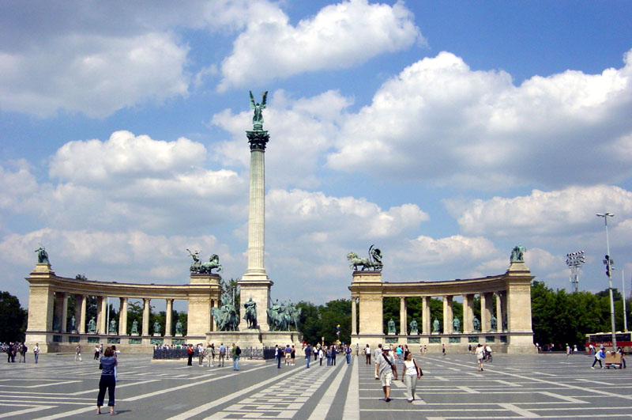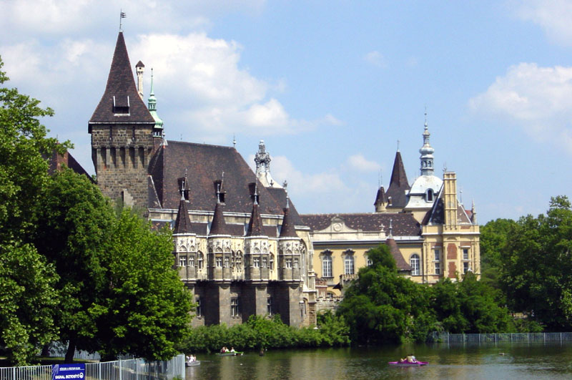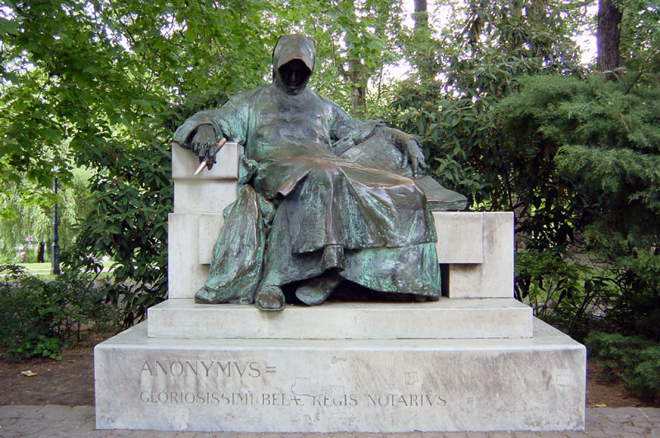
CANCELLATION POLICY
All cancellations must be sent in writing or e-mail to the course organisers (Lisa Ionescu or Lena Zani) in IFCC Office. Cancelled places will be filled up by the next candidate on the waiting list.

Cancellation of registration:
Registrations cancelled on or before 1 July 2005 will receive an 80% refund of the registration fee.
Cancellations between 2 July and 6 August 2005 will receive a 50% refund.
No refunds will be made after 6 August 2005.

Cancellation of hotel reservation in Hotel Taverna:
Cancellations received on or before 6 August 2005:
No charge will be made
Cancellations received after 6 August 2005:
45-30 days prior to expected arrival: Hotel will deduct 30% from any refund issued
30-21 days prior to expected arrival: Hotel will deduct 60% from any refund issued 21-1 days prior to expected arrival: Hotel will deduct 80% from any refund issued
Within 24 hours prior to expected arrival: No refund will be issued

GENERAL INFORMATION
Banks and currency
The currency in Hungary is Forint. Major credit cards are generally accepted in restaurants and shops. Small shops, ticket offices for local transport, and taxi drivers, however, do not accept cards. It is recommended to have some cash on you. Travellers’ cheques can be cashed at all banks, travel agents or hotels. There are many cash points around town which accept most international cards.

Climate and weather
Hungary’s climate is continental. The weather in September can be variable, from sunny and mild Indian summer to wet and windy autumn with an average temperature of 18-20 ºC. For weather forecast information see http://weather.cnn.com or http://weather.yahoo.com.

Tourism
For more information on Hungary please visit the following sites: http://hungary.ohb.hu, www.hungarytourism.hu or http://www.traveltohungary.com

Sponsors
The course is sponsored by IFCC, FESCC, the Hungarian Society of Clinical Pathology and Roche Diagnostics Hungary.


REGISTRATION FORM
The form is downloadable at: www.ifcc.org
Deadline for registration: 15 May 2005
Please complete this form electronically or using BLOCK CAPITALS

Individual’s personal data:
Title: Prof Dr Mr Mrs Ms Other:
First name: Family name:
Organisation:
Address:

City: Post Code/Zip Code:
Country: Tel:
Fax: Email:

Background in EBM/EBLM (max 250 words – can be attached on separate sheet):

Learning objectives (Please tick relevant boxes below and/or describe those areas which you would like to learn about or discuss at the workshop):
Basic methods and skills in EBM/EBLM Searching for the evidence
Critical appraisal of the literature Systematic reviewing skills
Analysis and synthesis of data Guideline development skills
Getting research into practice Training skills in EBLM
Other (please specify):
Registration fee per person (Please tick box for your choice of payment and enter sum below)
Registration fee before 1 July 2005: €uro 300 €
Registration fee after 2 July 2005: €uro 400 €
On site registration: €uro 450 (Cash only) €
Welcome reception (included in registration fee): I wish to attend (tick box)
Course dinner (included in registration fee): I wish to attend (tick box)
Sightseeing in Budapest (25 September, not included in fee): I wish to attend (tick box)
I wish to register for the IFCC/FESCC EBLM Course:
Signature: Date:
Please complete and return this form by fax or mail to the following address:
IFCC Office. Via Carlo Farini 81, 20159 Milano, Italy
Tel: + 39 02 6680 9912
Fax: + 39 02 6078 184
HOTEL BOOKING FORM
The form is downloadable at: www.ifcc.org
Deadline for booking: 15 May 2005
Please complete the form electronically or using BLOCK CAPITALS

The form can be used for bookings in Hotel Taverna only. If you wish to book another hotel, please secure your accommodation on an individual basis.
To secure your accommodation in the conference venue, please return the hotel booking form together with your registration form by 15 May 2005. Hotel bookings and rates cannot be guaranteed after this date. Your booking form and credit card details will be forwarded to the hotel to secure your reservation. The hotel will send you a confirmation of your booking.
If you wish to make any changes to your hotel reservation after the hotel confirmed your booking, please contact the hotel directly. For cancellations, see our cancellation policy on page 7.
Participants must settle their accounts with the hotel on departure.

Personal requirements
Please give details of any dietary requirements or concerns relating to any difficulties (visual, hearing, access, allergies, etc.).

Please complete and return this form by fax or mail to the following address:
IFCC Office
Via Carlo Farini 81, 20159 Milano, Italy
Tel: + 39 02 6680 9912
Fax: + 39 02 6078 1846

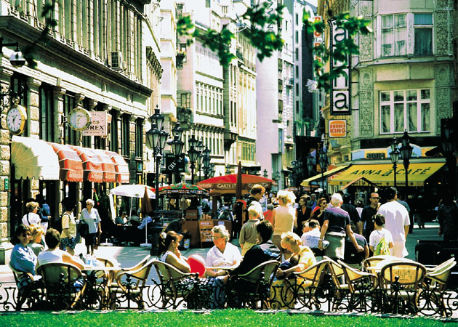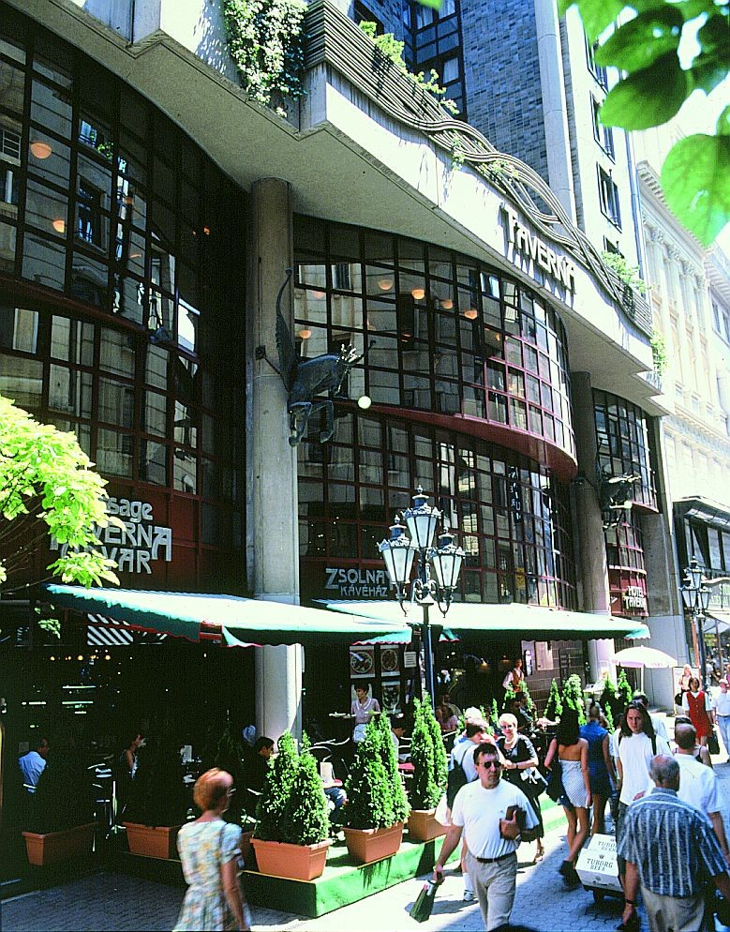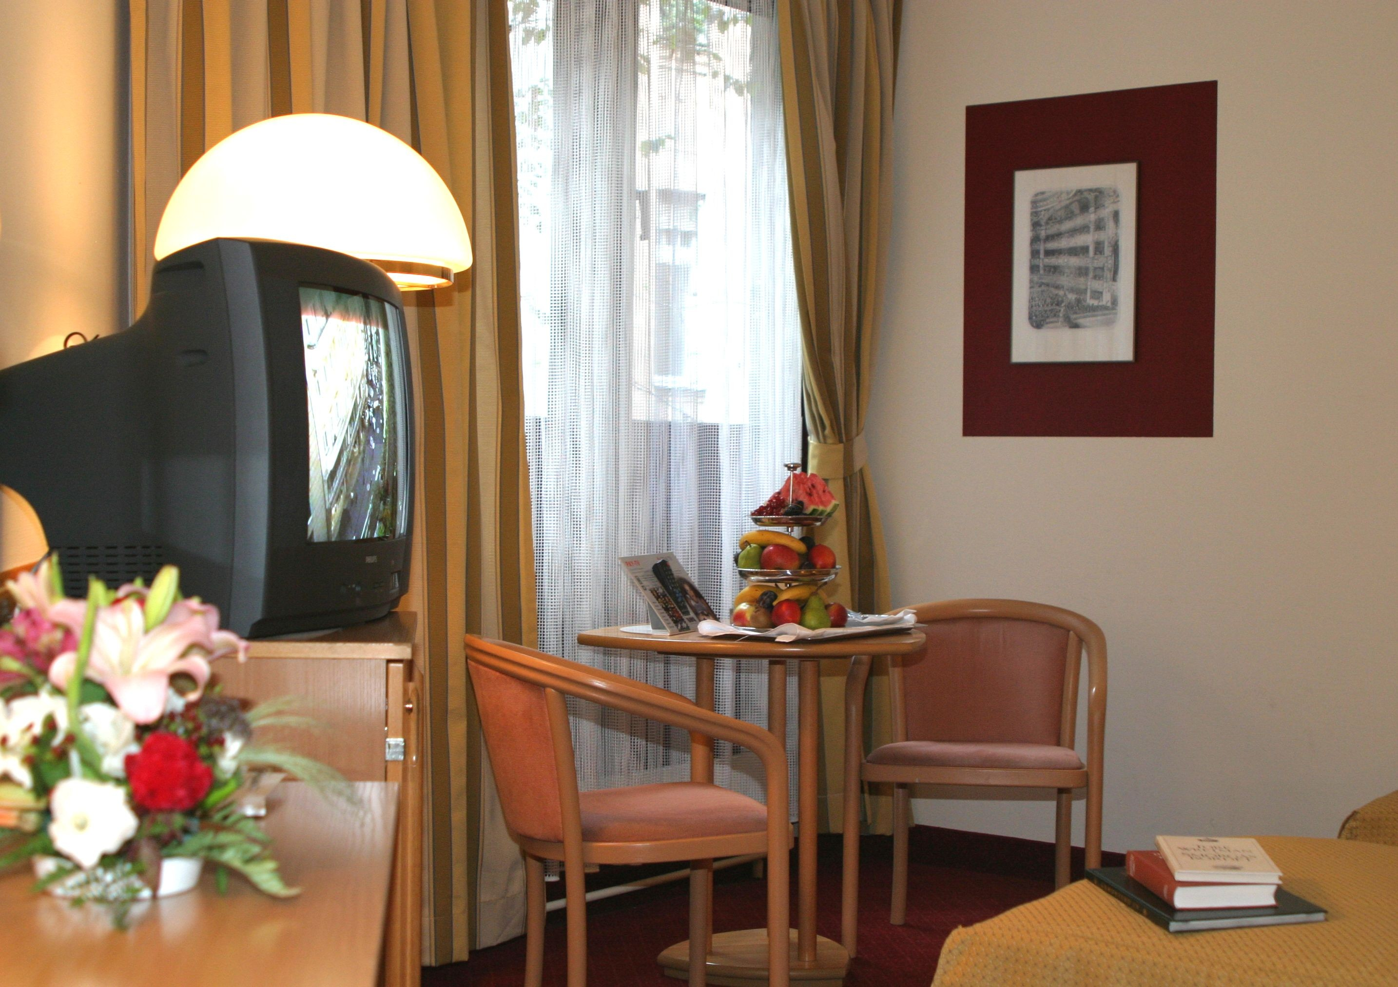


Hotel Taverna
1052 Budapest, Váci u. 20. Reservation Deadline: 15 May 2005
Phone: (36-1) 485-3100 After this date, the Hotel Taverna will not

Fax: (36-1) 485-3111 be able to guarantee availability, and

E-mail: hotel@hoteltaverna.hu reservations will be made on room and rate
Internet: www.hoteltaverna.hu availability basis.

Reservation Form For Accommodation
IFCC/FESCC COURSE ON EVIDENCE-BASED LABORATORY MEDICINE

Name of Guest: _________________________________________________
Company: _________________________________________________
Address: _________________________________________________
Phone: _______________________ Fax: _____________________
Please reserve:  Single room EUR 95,-
 Double room EUR 120,-
 Car Parking EUR 24,-
* The above special rates are per room /night and include buffet-breakfast and tax.
Check-in time: 15h00 Check-out time: 12h00
I would like:  Non-Smoking room (limited)  Smoking room
Arrival: (Day & Time) ________________________________________________
Departure: (Day & Time) ________________________________________________
I guarantee my reservation:  by Cash  by Credit Card*
Card Type:  Visa  Eurocard / Mastercard
 American Express  Diners Club
Card Number: ______________________ Expiry Date: _____________
Cardholder’s Name (please print): __________________________________________

Signature of cardholder: Date:
- Confirmed as guaranteed arrival!
- In case of no-show we charge two nights penalty. Please let us know your credit card number and validity as a guarantee of the reservation. In case of a non-guaranteed reservation, we can only hold the room until 6 p.m.

Please complete and return this form by fax or mail to the following address:
IFCC Office, Via Carlo Farini 81, 20159 Milano, Italy
Tel: + 39 02 6680 9912
Fax: + 39 02 6078 1846

